Installer Documentation

Purpose
The purpose of this document is to explain the packaging of the YAWL installer, ans especially how IzPack is configured to work as an installer for the YAWL workflow system.

Packaging Tools
To build the installer, three tools are required:
- Ant
- Launch4J
- IzPack

Ant

Launch4j
- launch4jconfig.xml
- UninstallConfig.xml

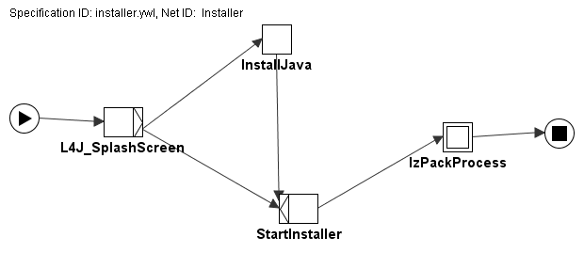

IzPack
Configuring IzPack consists of setting up a set of panels, the order of these panels, and what each panel will do. IzPack comes standard with a set of default panels. Some of these have been extended by adding code.

To change the installer process to suit other YAWL systems, the programmer must change one or more of the panels.

The panels are defined in “YAWL Installer.xml” as follows:
<panels>
<panel classname="HelloPanel"/>
<panel classname="LicencePanel"/>
<panel classname="PacksPanel"/>
<panel classname="PackageDependentUserInputPanel"/>
<panel classname="PackageDependentUserInputPanel"/>
<panel classname="TargetPanel"/>
<panel classname="InstallPanel"/>
<panel classname="ProcessPanel"/>
<panel classname="ShortcutPanel"/>
<panel classname="HTMLInfoPanel"/>
<panel classname="SimpleFinishPanel"/>
</panels>

These is the order each of the panels will be displayed in. Each of the panels are associated with a resource. The resource determines the configuration of the panel. Resources are defined as follows:
<resources>
<res id="HTMLInfoPanel.info" src="install-readme.html"/>
<res id="userInputSpec.xml" src="userInputSpec.xml"/>
<res id="shortcutSpec.xml" src="shortcutSpec.xml"/>
<res id="TargetPanel.dir.windows" src="TargetPanel.dir.windows.xml"/>
<res id="Installer.image" src="graphics/yawl_rotate.jpg" />
<res id="LicencePanel.licence" src="Licencepanel.txt" />
<res id="ProcessPanel.Spec.xml" src="ProcessPanel.xml"/>
</resources>

The id field indicates which panel the resource defines, and the src field links to a particular file.

The process shown below illustrates how these panels work in order.
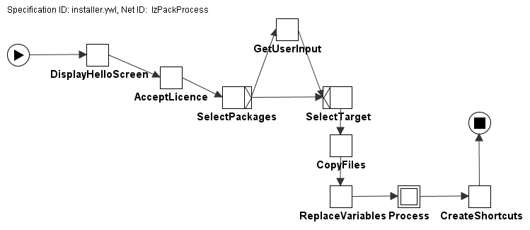
The Display Hello Screen task will first use the HelloPanel to welcome the user to the YAWL Installer. The values for the hellopanel are defined in the YAWL-Installer.xml file.
<info>
<appname>YAWL - Workflow System</appname>
<appversion>1.0</appversion>
<authors>
<author name="YAWL Foundation" email=" enquiry@yawlfoundation.org"/>
</authors>
<url>http://www.yawl-system.com/</url>
<webdir>http://localhost:8080/yawlpackages</webdir>
<javaversion> 1.5 </javaversion>
</info>
All of these are pretty self explanatory, and are simply displayed in the welcome screen. The webdir field is used when building a web-installer. A web-installer is a small executable which contains none of the packages. After a user selects the required packages, they are downloaded on-demand from this website.

The AcceptLicence is displayed afterwards. In order to continue the installation, the user must accept the licence. The licence text displayed is read from the resource file associated with this panel
(<res id="LicencePanel.licence" src="Licencepanel.txt" />)

Then the SelectPackages task will display the list of available packages. The packages in the YAWL Installer are defined in the YAWL-installer.xml file.
<packs>
<pack name="YAWL Engine" required="yes">
<description>Main YAWL Engine parts</description>
<file src="yawl.war" targetdir="$INSTALL_PATH"/>
<file src="library" targetdir="$INSTALL_PATH"/>
<singlefile src="yawlXForms.war" target="$INSTALL_PATH\yawlXForms.war"/>
<parsable targetfile="$INSTALL_PATH\InterfaceAServlet-servlet.xml"/>
</pack>
<pack name="YAWL Editor" required="no">
<description>YAWL Workflow Editor</description>
<singlefile src="YAWLEditor1.4.jar" target="$INSTALL_PATH\YAWLEditor1.4.jar"/>
</pack>
<pack name="PostgreSQL Database" required="no">
<description>Postgres Database</description>
<singlefile src="postgresql-8.0-int.msi" target="$INSTALL_PATH\postgresql-8.0-int.msi"/>
</pack>
<pack name="Tomcat WebServer" required="no">
<description>Tomcat Web Container</description>
<singlefile src="apache-tomcat-5.5.17.exe" target="$INSTALL_PATH\apache-tomcat-5.5.17.exe"/>
</pack>
</packs>

Each <pack> element defines one package. In the YAWL installer, there are four packages, the engine, the editor, the database and tomcat. A <file> element inside the pack describes a file or directory which is part of this package. These files will be copied to the specified installation directory. $INSTALL_PATH is a standard IzPack variable used to refer to the installation directory the user selects. <parsable> is used to parse files after copy, to replace variables in configuration files with user-selected options. In this case we parse the InterfaceAServlet-servlet.xml file to ensure that it has the correct database configuration.

The next step is to either accept user input or to select the installation target. The packageDependentUserInputPanel is a class which is NOT in the standard IzPack set. The purpose of this is to accept user input only if the user has not selected a particular package. For example, if the user selects to install tomcat, then it will be installed with YAWL in the selected target. If the user selects to use an existing tomcat installation, then he is prompted to give the details of the existing tomcat installation.

The second input panel is the similar. If the user does not want to install postgres, it will ask the user if he wants to use an existing postgres installation, or to disable database persistence all together.

It could be possible to allow users to use existing databases, the problem is that the JDBC driver required for these must also be copied into the correct directory where hibernate can find it. Therefore using other databases beyond PostgreSQL is left up to the individual user.

The Select Target task is then used to select where the YAWL files will be copied to. The default target is c:\progra~1\YAWL (this corresponds to c:\program files\yawl). The reason the target is defined using the MS-DOS 8 character version, is because during the processing step, it is difficult to install the DB with the space in the filename.

After this panel has been completed, all files belonging to the selected packages are copied over to the target.

Then the Replace task will replace all variables defined in various text files with variables defined in the installer. This is for example used to configure the database correctly. Files to be parsed by the installer are marked by “<parsable>” in the YAWL Installer.xml file.

After the replace task has occurred, the processing takes place. Processing is defined in the ProcessPanel.xml file. The details of this are explained in a separate section, but it basically installs tomcat and/or postgres as well as copies *.war files to the correct location.

The final parts of the installer, consists of providing users with a chance to create shortcuts. Shortcuts are defined in the shortcutSpec.xml file. Some shortcuts are duplicated in this file, for example for starting tomcat. The reason for this is that the installer creates default shortcuts in case tomcat already existed. If tomcat was installed with YAWL, this shortcut is then overridden and replaced with the new installation of tomcat.

Shortcuts are defined using variables such as $tomcat_home and $Install_path. If tomcat is already installed, the tomcat_home variable is used, otherwise the install_path variable is used to locate tomcat. IzPack does not have the facility to assign the value of one variable to another, and therefore the default-overwrite method described in the previous paragraph is used.

Then the user is presented with a panel describing how to start YAWL, and finally a message saying that the installation is completed.

Processing

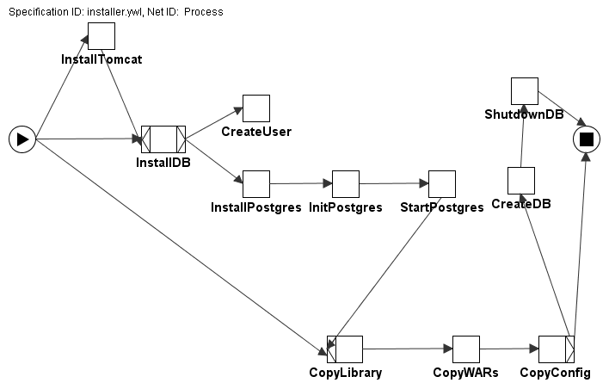

The processing sequence is quite complex and is defined in the ProcessPanel.xml file

Configuration Tool

Configuration files are in: Tomcat common/classes
Uninstaller

Required engine files
- config tool – installer.xml (target: build_configtool)
- standalone – build_Standalone
- editor – ask lindsay
- engine.wars – build using installer.xml (build_All)
- library -

Changed IzPack files

